# **Developing a Framework for Integrated Project & Context-Based Learning in ICT Education**

*J. Muller & JJ Greeff*

# **Introduction**

The rapid evolution of Information and Communication Technology (ICT) education has created a pressing need for innovative teaching and learning methodologies that better equip students with practical, industry-relevant skills (Khasawneh, 2024). Traditional assessment methods often lack the integration of real-world applications, leading to a disconnect between academic theory and industry practice (Janse van Rensburg, 2022). The challenge lies in designing a framework that not only enhances student engagement but also promotes competency-based learning through project-driven and context-aware education, as expressed by Pratisto and Danoetirta (2025) and Molina-García et al. (2024).

This study addresses this challenge by proposing an **Integrated Project & Context-Based Learning (IPCBL) framework**, which merges project-based learning, context-based learning, and integrated learning methodologies into a cohesive approach. The primary research objective is to develop and evaluate a framework that fosters deep learning, problem-solving, and skill acquisition within an ICT education context. The study aims to propose a framework that can be used to bridge the gap between the undergraduate Information Technology (IT) studies and the IT industry.

The decision to adopt project-based, context-based, and integrated learning approaches in this initial framework was intentional, serving as a foundational step in exploring pedagogies that bridge academic theory and industry application. These three were selected due to their proven alignment with real-world ICT practices and their complementary strengths in promoting critical thinking, practical skill development, and interdisciplinary learning. However, this selection is not exhaustive; it provides a starting point for iterative research. Future iterations of the study will explore additional approaches - such as game-based learning - to further enhance and adapt the framework for diverse learning contexts and technological advancements.

# **Research Method**

Design Science Research (DSR) can be used as a research methodology that promotes the creation of innovative and practical solutions to real-world problems. According to Gregor and Hevner (2013), DSR involves the systematic development and evaluation of artefacts (including frameworks, systems, theories or applications) that are designed to address specific problems. Gregor et al. (2020) suggest that DSR enables design, implementation, and evaluation of new information systems and technologies. *Vaishnavi (2007) notes that DSR is an iterative process that involves the application of design principles and techniques to create new knowledge and solutions.*

Vaishnavi (2007) notes that the use of iterative DSR cycles allow researchers to refine and improve solutions through the process of continuous evaluation, testing, feedback and refinement. Cennamo and Kalk (2019) and Zydney et al. (2020) similarly argue that *iterative cycles are an essential aspect of DSR, as they enable researchers to develop and refine their solutions based on feedback from end-users and stakeholders.*

Figure 1 illustrates how the existing knowledge contribution of other researchers will be used as the foundation for gaining awareness of the problem before iteratively developing a framework (through various steps) that contribute back to the knowledge base in various ways.

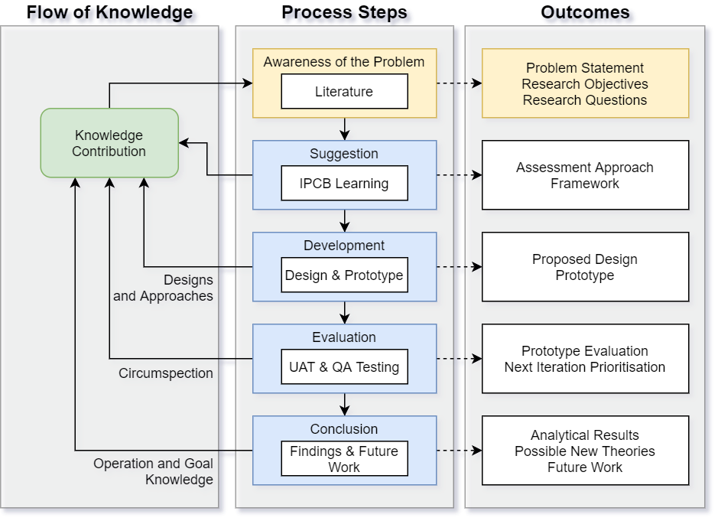

Figure 1: Research Method

By incorporating multiple evaluation and/or feedback loops and cycles of testing and refinement, DSR researchers can improve the quality as well as effectiveness of their artifacts to ensure that they are well-suited to the function and non-functional requirements. This iterative approach allows for the creation of practical *and* *innovative solutions that are well-grounded in the realities of the problem domain.*

In this study, the framework was developed iteratively, leveraging insights from existing research while refining the implementation through multiple evaluation loops. The problem being addressed is the need for an effective and scalable approach to integrating project- and context-based learning within ICT education.

# **Combining Learning Approaches**

The field of ICT education has undergone significant changes in recent years, driven by the need to prepare students for the rapidly evolving digital world (Vassilakopoulou and Hustad, 2021). Wang et al. (2022)position the integration of different concepts with learning which motivates the approach of combining of project-based, context-based, and integrated learning approaches. The aim is to involve engaging students in real-world projects that are situated within relevant contexts and require the integration of different disciplines as well as skills. By combining learning approaches, ICT educators aim to provide students with a comprehensive and immersive learning experience that prepares them for the demands of the digital workforce (Truong, 2016).

## **Integrated Learning**

Integrated learning refers to a teaching and learning approach that connects different academic disciplines, skills, and experiences to promote deeper understanding and transferable skills (Ali, 2020). According to Huber and Panel (2005), integrated learning can be defined as a curriculum design connecting different forms of academic disciplines, modes of inquiry and knowledge to deal with complex problems.

Integrated learning can take various forms, including interdisciplinary and multidisciplinary courses, team-taught courses, service learning, and experiential learning (Sabbir and Taufique, 2022). As proposed by Klein (2005) and supported by AlAli (2024), the goal of integrated learning is to provide students with a holistic and interdisciplinary perspective that prepares them for real-world challenges and promotes lifelong learning.

Integrated learning has been found to have numerous benefits for students, including improved critical thinking, problem-solving, communication, and collaboration skills. It also promotes creativity, innovation, and adaptability, which are essential in today's rapidly changing world (Klein, 2009). Overall, integrated learning is a valuable educational approach that can help students develop essential skills and knowledge while also promoting their motivation and interest in academic disciplines. Integrated learning can also be complimented by industry-relevant certifications that recognise the academic skills that are sufficient for practical implementation.

## **Project-Based Learning**

Project-based learning (PBL) is an educational approach that introduces students to real-world projects that enable their development of essential knowledge and skills (Guo et al., 2020). As put forward by Widiyati and Pangesti (2022) - in project-based learning, students work collaboratively to investigate and respond to complex questions, problems, or challenges, using critical thinking, problem-solving, and decision-making skills. They typically engage in a process of inquiry, design, and reflection, with the goal of developing deep understanding and transferable skills (Bell et al., 2010)*.*

According to Guo et al. (2020) and supported by Boss and Krauss (2022), PBL has been found to have numerous benefits for students which included improved motivation, engagement and achievement. It also promotes the development of essential skills (like communication, collaboration, creativity and innovation) which are highly valued in professional workspaces, as seen in the Slovakian study done by Maros et al. (2023) . PBL is a valuable educational approach that helps students develop the essential skills and knowledge needed to be productive participants of the workforce, while promoting motivation and interest in academic disciplines (Janse van Rensburg, 2022).

## **Context-Based Learning**

Context-based learning is referred to as an educational approach that incorporates real-world problems and challenges, allowing students to learn through practical application and inquiry-based learning (Javed et al., 2021). This approach allows students to work collaboratively to develop and implement solutions addressing issues within specific communities or societies, applying academic knowledge to real-world contexts to enhance the students skillset (Nittayathammakul et al., 2021).

According to Krajcik et al. (2008), context-based learning is an effective way to engage students while creating learning environments that are industry-relevant. This approach allows students to see the practical applications of technology and the effect it has on day-to-day activities. Context-based learning encourages students to develop the relevant problem-solving skills (like critical thinking and communication skills). Additionally, context-based learning also increases student motivation and interest in their domains, as well as improve their professional literacy (Liu et al., 2020).

## **Integrated Project & Context-Based Learning**

The goal of IPCBL is to combine the individual approaches of context-based learning, project-based learning and integrated learning with the aim of realising the benefits of each separate approach when they are all brought together.

Figure 2: Integrated Project & Context-Based Learning

As illustrated in Figure 2, all projects within a specific module are given within a specific context or problem. Each project, referred to as a capstone project, is subject to its own nature and discipline that students need to acquire to complete the project – they need to develop the fundamental subject matter expertise. In retrospect, the composition of each project will contribute to the integrated-learning aspect of the module as the composition of each project should replicate a real-world scenario, ideally resulting in differing compositions for each project.

# **Technical Considerations**

## **Technology Considerations**

IPCBL can be achieved through initiatives spanning across various technological solutions, with different automation tools, data visualisation platforms, and cloud-based services offering viable alternatives, in ICT based projects.

For automation, UiPath or Automation Anywhere could be used instead of Power Automate. Similarly, while Power BI was selected for data visualisation, equivalent functionality could be achieved using Qlik or Tableau. For cloud-based services, Microsoft Azure was used, but other platforms such as AWS Lambda or Google Cloud Functions could provide similar functionality.

The selection of the specific technology stack in the use cases used as part pf this study were based on several factors. The balance between module outcomes and skills requirements from industry partners had to be mitigated through the projects. Integration with the existing university infrastructure, which includes a Microsoft-based LMS and Active Directory authentication, played a significant role in technical considerations as well. Ease of deployment and maintenance was also prioritised, alongside cost considerations relevant to the university setting. Additionally, personal expertise in the selected technologies enabled efficient development and implementation. These choices do not imply exclusivity but rather illustrate one possible approach to achieving an effective automated marking assistant.

## **Project & Context-Based Considerations**

The selection of projects and overarching context can be generalised to encompass any topic or address any problem, provided it does not violate regulatory, legal, or ethical considerations. The projects and contexts used in the case study were specifically aligned with the needs of relevant industry partners at the time. These can be adapted annually to reflect technological advancements.

During the study, the projects were focused on topics that were particularly relevant in the field throughout the study, providing a valuable contextual problem statement that could be broken down into smaller projects, each incorporating various concepts and technologies. The proposed approach was tested across three iterations, each representing a distinct use case with a different contextual premise, yet consistently producing the same deductions from the results.

Each project had it’s own context and business context briefing associated. At a high-level, the summary of the three iterations rendered interesting results, illustrated in the Figure 3:

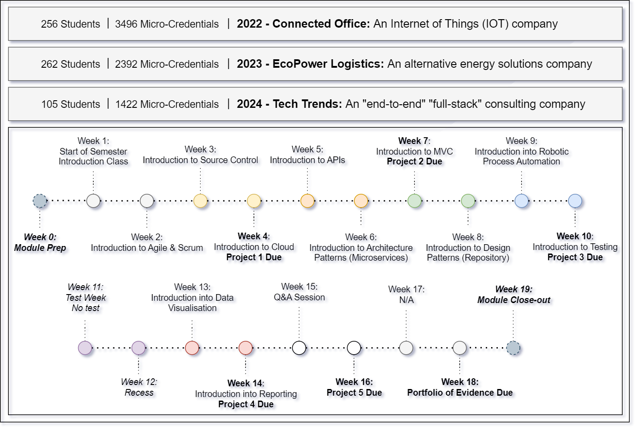

Figure 3: Previous Iteration Results

As seen in Figure 3, all three iterations had specific contexts associated to the project, while following the same semester structure. The third iteration included a smaller set of students. The study has seen over 600 students accumulate over 7 300 micro-credentials.

## **Validation Considerations**

As part of the initiative to integrate student skills development with industry requirements, it is essential to ensure that the skills being developed align with both academic and industry expectations. From an academic perspective, the completion of a degree serves as validation that the module outcomes have been achieved. From an industry perspective, the skills acquired are assessed against industry certification standards. To evaluate the success of this initiative, students should be able to translate their academic knowledge into an industry-recognised certification. As part of the use case, the concept of industry training and certification was also incorporated.

# **Connected Office Use Case: Analysis of Results**

As part of an experiment trialled for six months within an IT development module, specifically focused on assisting students with the adaptation of new technologies and polishing their integration skills, students were given a high-level technical architecture with an overarching context for all content delivered throughout the semester. The overarching theme was “Connected Office” relating to the concept of the Internet of Things (IoT). All concepts were introduced to students within the Connected Office context, even from a theoretical perspective. Figure 4 illustrates the high-level technical architecture presented to students to explain the layers of the architecture that they would be working with throughout the semester, in different capstone projects, all tying back into the main IoT theme.

Figure 4: Module Context

A continuous learning approach was used in the module to assess students, with a portfolio of evidence (POE) submitted by the students at the end of the semester to show the work they had managed to complete throughout the semester, along with community contribution and external training (badges and certifications). This was done through the incorporation of external micro-credentials provided by industry reputable providers (like UiPath, LinkedIn and Microsoft) to recognise a student’s achievement of specific skills, knowledge, or competencies.

As illustrated by Figure 5, each project was issued as a capstone project with all white blocks outlined in black demonstrating where new components had to be created as part of the designated project. All grey blocks refer to pre-developed components (from previous projects) that had to be reused to complete the objectives, changing the composition of each project while remaining separate capstone projects, all relating to the overarching IoT theme within the module context.

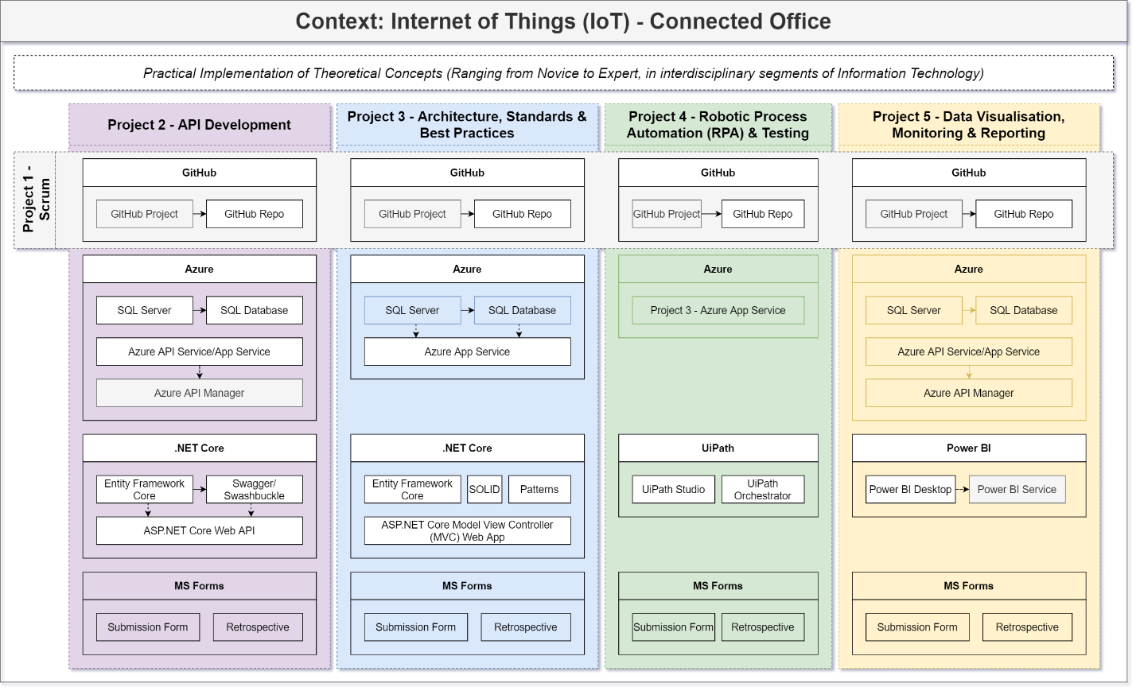

Figure 5: Implemented Integrated Project Context-Based Learning

The context provided by Figure 5, enabled the introduction of external training and certification by well-respected issuers, like Microsoft and UiPath, related to the content and context of the module. Figure 6 demonstrates how each project encapsulated recommended external training, resulting in external certifications, relating to the context of each capstone project as well as the context of the module as a whole. The white blocks, outlined with black borders depicts new categories of skills that need to be acquired whereas the transparent blocks assume the skills mastered through the completion of previous projects, adding to the integrated disciplinary nature of all of the capstone projects. The white blocks illustrate additional knowledge to be acquired through the module which will be coupled with external micro-credentials.

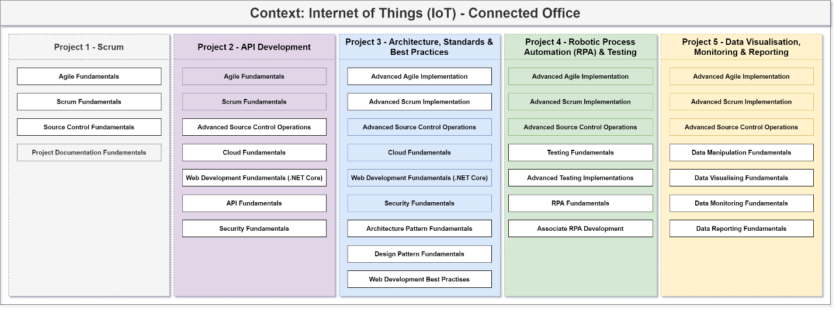

Figure 6: Implemented Integrated Project Context-Based Learning with Certification Paths

As a result of this approach, across approximately 256 students, 3 495 certifications were achieved, of which 2 914 were badges. Majority of the students obtained 11 badges and 2 certifications, on average. Figure 7 illustrates the division of certifications and badges across major categories, in alignment with the capstone projects. The highest number of certifications was obtained for API development, followed by data visualisation. The lowest number of certifications were obtained for the web development category which can be explained by the order of the capstone projects. Project 2 focused on API development using the same technical framework as web development which featured in Project 3, showing a growth in skills with a reduced need for upskilling as projects continued to build on top of one another.

Figure 7: Micro-Credentials (Badges and Certifications) Obtained

Apart from the iterative review of student feedback and continuous monitoring of student progress, the implementation of the proposed framework was evaluated using Quality Assurance (QA) and User Acceptance Testing (UAT) to identify any potential enhancements.

The criteria presented in Table 1 were selected based on established educational theory and best practices in ICT curriculum design. Sources such as Bell et al. (2010), Klein (2005), Javed et al. (2021), and Krajcik et al. (2008) highlight the significance of motivation, knowledge transfer, and real-world application as indicators of effective pedagogy. Additionally, the inclusion of external certification reflects current trends in aligning academic learning with industry benchmarks (Muller & Greeff, 2022).

|  |  |  |  |  |
| --- | --- | --- | --- | --- |
| **Advantage** | **Context-Based Learning** | **Project-Based Learning** | **Integrated Learning** | **Integrated Project Context-Based Learning** |
| Improved motivation & engagement | X | X | - | X |
| Improved retrospective understanding of critical concepts | X | X | X | X |
| Development of essential skills | X | X | - | X |
| Transferability of knowledge | X | X | X | X |
| Real-world application | X | X | X | X |
| Encourages critical thinking | X | X | X | X |
| Encourages creative thinking | - | - | X | X |
| Encourages problem solving | X | X | X | X |
| Encourages external training & certification | - | X | - | X |

Table 1: Advantages of Different Learning Approaches

The information represented in Table 1 shows that different learning approaches can be followed to realise benefit, however there are gaps that occur from using these approaches individually. When these approaches are combined, the benefits of all approaches are realised.

# **Future Work**

The learnings from this iteration of the study will enable the future iterations to encapsulate the evaluation feedback into the improvement of the approach as a framework. The future work items include:

* Encapsulate the approach proposed by Muller and Greeff (2022) to develop a curriculum shaped specifically to incorporate pre-defined skills that can be aligned to a module-outcome-level binary rubric.
* Enhance the template of the content required in the portfolio of evidence that illustrates the progression of student skills and application of knowledge through the IPCBL learning approach.
* Introduce external training milestones into the approach to ensure certificates are obtained timeously and within integrated capstone project context, contributing to the overarching module context.

# **Conclusion**

This study introduced the IPCBL framework as a solution to bridging the gap between academic learning and industry needs in ICT education. By integrating project-based learning and context-based learning, the framework promotes deep learning, problem-solving, and competency development. The study demonstrated that a structured, technology-agnostic approach to integrating students into the working environment effectively while maintaining academic integrity.

Future iterations of this research will refine the IPCBL framework through further empirical validation, ensuring that it remains adaptable to evolving educational and technological landscapes. Ultimately, the framework contributes to advancing ICT education by fostering a more integrated, skill-based, and industry-aligned learning environment.

# **References**

ALALI, R. 2024. Enhancing 21st century skills through integrated STEM education using project-oriented problem-based learning. *Geo Journal of Tourism and Geosites,* 53**,** 421-430.

ALI, W. 2020. Online and remote learning in higher education institutes: A necessity in light of COVID-19 pandemic. *Higher education studies,* 10**,** 16-25.

BELL, T., URHAHNE, D., SCHANZE, S. & PLOETZNER, R. 2010. Collaborative inquiry learning: Models, tools, and challenges. *International journal of science education,* 32**,** 349-377.

BOSS, S. & KRAUSS, J. 2022. *Reinventing project-based learning: Your field guide to real-world projects in the digital age*, International Society for Technology in Education.

CENNAMO, K. & KALK, D. 2019. *Real world instructional design: An iterative approach to designing learning experiences*, Routledge.

GREGOR, S., CHANDRA KRUSE, L. & SEIDEL, S. Research perspectives: the anatomy of a design principle. 2020. Association for Information Systems.

GREGOR, S. & HEVNER, A. R. 2013. Positioning and presenting design science research for maximum impact. *MIS quarterly***,** 337-355.

GUO, P., SAAB, N., POST, L. S. & ADMIRAAL, W. 2020. A review of project-based learning in higher education: Student outcomes and measures. *International journal of educational research,* 102**,** 101586.

HUBER, M. & PANEL, C. P. Integrative learning as an intellectual art. Association of American Colleges and Universities Network Conference on Integrative Learning, 2005. 1-7.

JANSE VAN RENSBURG, J. Project-based learning guidelines for IT higher education. ICT Education: 50th Annual Conference of the Southern African Computer Lecturers' Association, SACLA 2021, Johannesburg, South Africa, July 16, 2021, Revised Selected Papers, 2022. Springer, 67-81.

JAVED, U., SHAUKAT, K., HAMEED, I. A., IQBAL, F., ALAM, T. M. & LUO, S. 2021. A review of content-based and context-based recommendation systems. *International Journal of Emerging Technologies in Learning (iJET),* 16**,** 274-306.

KHASAWNEH, M. A. S. 2024. Closing the industry-academia gap in translation education; Exploring collaborative strategies as tools for effective curriculum alignment. *Kurdish Studies,* 12.

KLEIN, J. T. 2005. Integrative learning and interdisciplinary studies. *Peer Review,* 7**,** 8-10.

KLEIN, J. T. 2009. *Creating interdisciplinary campus cultures: A model for strength and sustainability*, John Wiley & Sons.

KRAJCIK, J., MCNEILL, K. L. & REISER, B. J. 2008. Learning‐goals‐driven design model: Developing curriculum materials that align with national standards and incorporate project‐based pedagogy. *Science education,* 92**,** 1-32.

LIU, X., XU, J., XU, X., WANG, Y. & CAO, Y. 2020. Context-based learning: A review of recent research and implications for science education. *Research in Science Education,* 50(1)**,** 155-178.

MAROS, M., KORENKOVA, M., FILA, M., LEVICKY, M. & SCHOBEROVA, M. 2023. Project-based learning and its effectiveness: evidence from Slovakia. *Interactive Learning Environments,* 31**,** 4147-4155.

MOLINA-GARCÍA, N., GONZÁLEZ-SERRANO, M. H., ORDIÑANA-BELLVER, D. & BAENA-MORALES, S. 2024. Redefining education in sports sciences: A theoretical study for integrating competency-based learning for sustainable employment in Spain. *Social Sciences,* 13**,** 242.

MULLER, J. & GREEFF, J. J. The Use of Binary Scales in Rubrics to Evaluate Computer Science Assessments. ICT Education: 51st Annual Conference of the Southern African Computer Lecturers' Association, SACLA 2022, Cape Town, South Africa, July 21–22, 2022, Revised Selected Papers, 2022. Springer, 58-72.

NITTAYATHAMMAKUL, V., CHATWATTANA, P. & PIRIYASURAWONG, P. Conceptual Framework of Crowd Context-Based Learning via IoT Wearable Technology to Promote Digital Health Literacy. 2021 5th International Conference on E-Society, E-Education and E-Technology, 2021. 113-119.

PRATISTO, E. H. & DANOETIRTA, D. R. 2025. Design and User Analysis of a Learning Management System: Student Competency-Based Learning. *IOTA Journal,* 5**,** 136-147.

SABBIR, M. M. & TAUFIQUE, K. M. R. 2022. Sustainable employee green behavior in the workplace: Integrating cognitive and non‐cognitive factors in corporate environmental policy. *Business Strategy and the Environment,* 31**,** 110-128.

TRUONG, H. M. 2016. Integrating learning styles and adaptive e-learning system: Current developments, problems and opportunities. *Computers in human behavior,* 55**,** 1185-1193.

VAISHNAVI, V. K. 2007. *Design science research methods and patterns: innovating information and communication technology*, Auerbach Publications.

VASSILAKOPOULOU, P. & HUSTAD, E. 2021. Bridging digital divides: a literature review and research agenda for information systems research. *Information Systems Frontiers***,** 1-15.

WANG, C., SHEN, J. & CHAO, J. 2022. Integrating computational thinking in STEM education: A literature review. *International Journal of Science and Mathematics Education,* 20**,** 1949-1972.

WIDIYATI, E. & PANGESTI, W. 2022. Project-based learning in teaching speaking to young learners: Is it effective? *EduLite: Journal of English Education, Literature and Culture,* 7**,** 71-81.

ZYDNEY, J. M., WARNER, Z. & ANGELONE, L. 2020. Learning through experience: Using design based research to redesign protocols for blended synchronous learning environments. *Computers & Education,* 143**,** 103678.